Faculty of Computing
Class: BSCS-2023-CD Course: CS-346 Compiler Construction

Lab 02: Lexical Analysis
Date: 29, Jan 2026

Lab Instructor: Ms. Urooj Akmal Instructor: Ms. Yusra

Submitted by:
Abrar Butt --- 460297 --- C

Introduction
A lexical analyzer (lexer/scanner) is the first phase of a compiler.
It:
- Reads the source code character by character ● Groups characters into tokens (meaningful units) ● Removes:
○ White spaces
○ Tabs
○ New lines
○ Comments
- Keeps track of line numbers for error reporting
Think of it as breaking code into words before grammar (parser) checks the sentence.

Objectives
1. Successful understanding/implementation Lexical Analysis in C/C++/Python

Tools/Software Requirements
- gcc / g++
- GNU Make or Visual Studio C++
- Any standard text editor or IDE

Lab Tasks
Below is the task students must complete.
Task Description:
We will be considering a subset of C/C++ language as our source language. In particular, your scanner implementation should return tokens for the following C/C++ features/specifications:
Arithmetic Operators: + - * / % ++ -- **
Relational Operators: == != > < >= <=
Assignment Operator: =
- Design a comprehensive DFA for the above language specifications using the guidelines given in class.
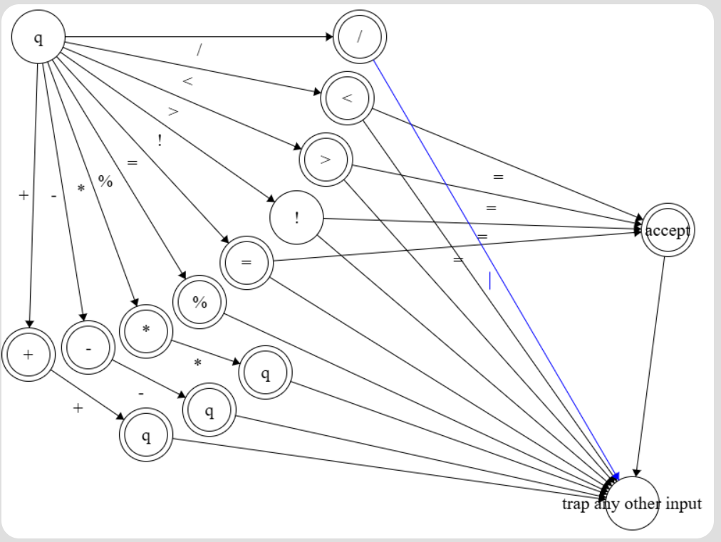

- Write skeleton code in C/C++/Python for the above DFA, including stub functions for whitespace/comments removal and Operator lookups.
Code:
Scanner.c
#include <stdio.h>
#include <stdlib.h>
#include <string.h>
#include <ctype.h>

/* =======================
TOKEN DEFINITIONS
======================= */

typedef enum {
TOKEN_KEYWORD,
TOKEN_IDENTIFIER,
TOKEN_INTEGER,
TOKEN_FLOAT,
TOKEN_ARITH_OP,
TOKEN_REL_OP,
TOKEN_ASSIGN_OP,
TOKEN_PUNCTUATOR
} TokenType;

/* =======================
KEYWORD TABLE
======================= */

char *keywords[] = {
"int","float","double","char","if","else","for",
"while","return","break","continue","void"
};

int isKeyword(char *lexeme) {
int n = sizeof(keywords) / sizeof(keywords[0]);
for (int i = 0; i < n; i++) {
if (strcmp(lexeme, keywords[i]) == 0)
return 1;
}
return 0;
}

/* =======================
WHITESPACE & COMMENTS
======================= */

void skipWhitespace(FILE *fp) {
char ch;
while ((ch = fgetc(fp)) != EOF) {
if (!isspace(ch)) {
ungetc(ch, fp);
break;
}
}
}

void removeSingleLineComment(FILE *fp) {
char ch;
while ((ch = fgetc(fp)) != '\n' && ch != EOF);
}

void removeMultiLineComment(FILE *fp) {
char ch, prev = 0;
while ((ch = fgetc(fp)) != EOF) {
if (prev == '*' && ch == '/')
break;
prev = ch;
}
}

/* =======================
IDENTIFIER / KEYWORD
======================= */

void handleIdentifier(FILE *fp, char firstChar) {
char buffer[50];
int i = 0;
char ch;

buffer[i++] = firstChar;

while ((ch = fgetc(fp)) != EOF && (isalnum(ch) || ch == '_')) {
buffer[i++] = ch;
}

buffer[i] = '\0';
ungetc(ch, fp);

if (isKeyword(buffer))
printf("KEYWORD : %s\n", buffer);
else
printf("IDENTIFIER : %s\n", buffer);
}

/* =======================
NUMBERS
======================= */

void handleNumber(FILE *fp, char firstChar) {
char buffer[50];
int i = 0, isFloat = 0;
char ch;

buffer[i++] = firstChar;

while ((ch = fgetc(fp)) != EOF) {
if (isdigit(ch))
buffer[i++] = ch;
else if (ch == '.') {
isFloat = 1;
buffer[i++] = ch;
} else {
ungetc(ch, fp);
break;
}
}

buffer[i] = '\0';

if (isFloat)
printf("FLOAT : %s\n", buffer);
else
printf("INTEGER : %s\n", buffer);
}

/* =======================
SYMBOL TABLE (STUB)
======================= */

void addToSymbolTable(char *lexeme) {
// Stub function (for Part II)
}

/* =======================
DFA DRIVER
======================= */

void lexicalAnalyzer(FILE *fp) {
char ch;
int lineNo = 1;

while ((ch = fgetc(fp)) != EOF) {

if (ch == '\n')
lineNo++;

if (isspace(ch)) {
skipWhitespace(fp);
}
else if (ch == '/') {
char next = fgetc(fp);
if (next == '/')
removeSingleLineComment(fp);
else if (next == '*')
removeMultiLineComment(fp);
else {
ungetc(next, fp);
printf("ARITH OP : /\n");
}
}
else if (isalpha(ch) || ch == '_') {
handleIdentifier(fp, ch);
}
else if (isdigit(ch)) {
handleNumber(fp, ch);
}
else if (ch == '=') {
char next = fgetc(fp);
if (next == '=')
printf("REL OP : ==\n");
else {
ungetc(next, fp);
printf("ASSIGN OP : =\n");
}
}
else if (ch == '+' || ch == '-' || ch == '*' || ch == '%') {
printf("ARITH OP : %c\n", ch);
}
else if (ch == '<' || ch == '>') {
char next = fgetc(fp);
if (next == '=')
printf("REL OP : %c=\n", ch);
else {
ungetc(next, fp);
printf("REL OP : %c\n", ch);
}
}
else {
printf("PUNCTUATOR : %c\n", ch);
}
}
}

/* =======================
MAIN FUNCTION
======================= */

int main() {
FILE *fp = fopen("input_scanner.c", "r");

if (fp == NULL) {
printf("Error opening file\n");
return 1;
}

lexicalAnalyzer(fp);
fclose(fp);
return 0;
}
File input_scanner.h
#include <stdio.h>
#include <math.h>

#define PI 3.14159265359

/* This program does some arbitrary calculations
* including area, volume and floating point ratios etc.
*/

int main(){
float area, volume; /* Output Variables */
int radius = 5; // Radius of Circle & Sphere
int num;

float X = -44.15;
float Y = 416.0e+1;
float Z = X / Y; /* Just to get a ratio, for no obvious reasons :)*/

for (num = 0; num < 10; num++){
printf("The Number is: %d\n", num); // Again a loop for the sake of being a loop ;)
}

area = PI * radius * radius; // Lets see if your pre-processor works!
volume = (4.0/3.0) * PI * radius * radius * radius; /* Here again !! */

printf("Area: %f, Volume: %f\n", area, volume);
return 0; /// We are done! Are we ?
}

Output:
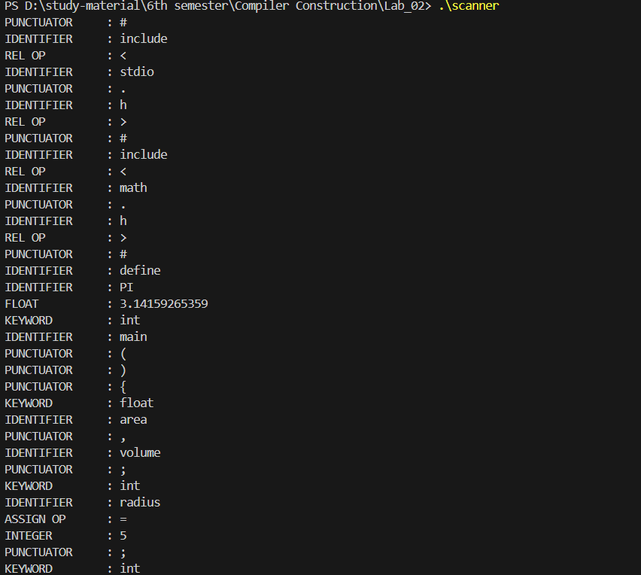
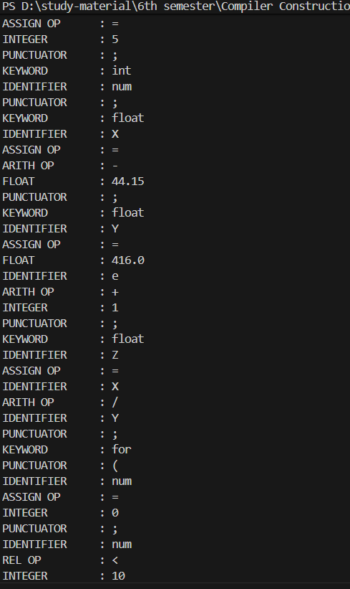
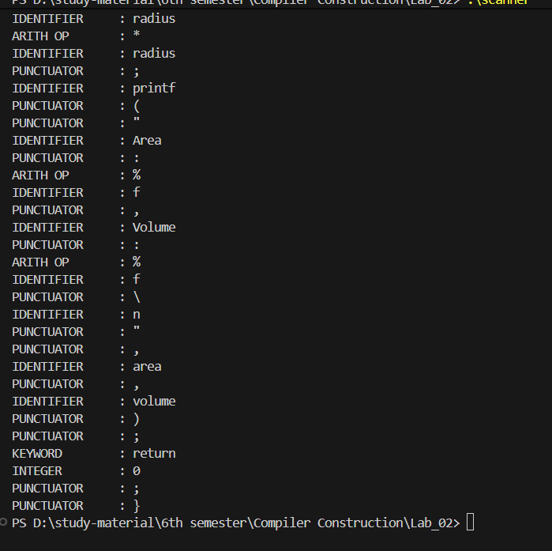

- Write code for removing comments from the source code
  - Single line comments
  - Multi-line comments
Input:
#include <stdio.h>
#include <stdlib.h>

void removeComments(FILE *in, FILE *out) {
char ch, next;

while ((ch = fgetc(in)) != EOF) {

if (ch == '/') {
next = fgetc(in);

// Single-line comment
if (next == '/') {
while ((ch = fgetc(in)) != '\n' && ch != EOF);
fputc('\n', out);
}

// Multi-line comment
else if (next == '*') {
char prev = 0;
while ((ch = fgetc(in)) != EOF) {
if (prev == '*' && ch == '/')
break;
prev = ch;
}
}

// Not a comment
else {
fputc(ch, out);
ungetc(next, in);
}
}
else {
fputc(ch, out);
}
}
}

int main() {
FILE *in = fopen("input_scanner.c", "r");
FILE *out = fopen("output_no_comments.c", "w");

if (in == NULL || out == NULL) {
printf("File error\n");
return 1;
}

removeComments(in, out);

fclose(in);
fclose(out);

printf("Comments removed successfully.\n");
return 0;
}

Input code:
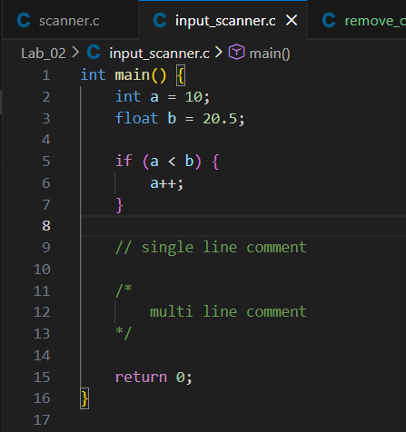
Output:
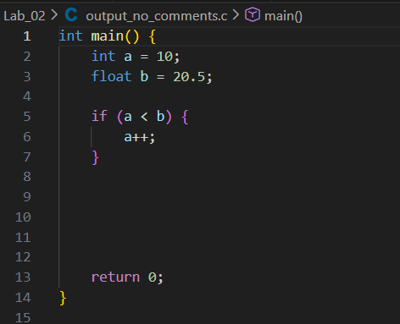
- Test your implementation using the “input_scanner.c” and “input_scanner.h” source files provided on LMS.
Output for the input_scanner.h: file no. 1
PS D:\study-material\6th semester\Compiler Construction\Lab_02> .\scanner
PUNCTUATOR : #
IDENTIFIER : include
REL OP : <
IDENTIFIER : stdio
PUNCTUATOR : .
IDENTIFIER : h
REL OP : >
PUNCTUATOR : #
IDENTIFIER : include
REL OP : <
IDENTIFIER : math
PUNCTUATOR : .
IDENTIFIER : h
REL OP : >
PUNCTUATOR : #
IDENTIFIER : define
IDENTIFIER : PI
FLOAT : 3.14159265359
KEYWORD : int
IDENTIFIER : main
PUNCTUATOR : (
PUNCTUATOR : )
PUNCTUATOR : {
KEYWORD : float
IDENTIFIER : area
PUNCTUATOR : ,
IDENTIFIER : volume
PUNCTUATOR : ;
KEYWORD : int
IDENTIFIER : radius
ASSIGN OP : =
INTEGER : 5
PUNCTUATOR : ;
KEYWORD : int
IDENTIFIER : num
PUNCTUATOR : ;
KEYWORD : float
IDENTIFIER : X
ASSIGN OP : =
ARITH OP : -
FLOAT : 44.15
PUNCTUATOR : ;
KEYWORD : float
IDENTIFIER : Y
ASSIGN OP : =
FLOAT : 416.0
IDENTIFIER : e
ARITH OP : +
INTEGER : 1
PUNCTUATOR : ;
KEYWORD : float
IDENTIFIER : Z
ASSIGN OP : =
IDENTIFIER : X
ARITH OP : /
IDENTIFIER : Y
PUNCTUATOR : ;
KEYWORD : for
PUNCTUATOR : (
IDENTIFIER : num
ASSIGN OP : =
INTEGER : 0
PUNCTUATOR : ;
IDENTIFIER : num
REL OP : <
INTEGER : 10
PUNCTUATOR : ;
IDENTIFIER : num
ARITH OP : +
ARITH OP : +
PUNCTUATOR : )
PUNCTUATOR : {
IDENTIFIER : printf
PUNCTUATOR : (
PUNCTUATOR : "
IDENTIFIER : The
IDENTIFIER : Number
IDENTIFIER : is
PUNCTUATOR : :
ARITH OP : %
IDENTIFIER : d
PUNCTUATOR : \
IDENTIFIER : n
PUNCTUATOR : "
PUNCTUATOR : ,
IDENTIFIER : num
PUNCTUATOR : )
PUNCTUATOR : ;
PUNCTUATOR : }
IDENTIFIER : area
ASSIGN OP : =
IDENTIFIER : PI
ARITH OP : *
IDENTIFIER : radius
ARITH OP : *
IDENTIFIER : radius
PUNCTUATOR : ;
IDENTIFIER : volume
ASSIGN OP : =
PUNCTUATOR : (
FLOAT : 4.0
ARITH OP : /
FLOAT : 3.0
PUNCTUATOR : )
ARITH OP : *
IDENTIFIER : PI
ARITH OP : *
IDENTIFIER : radius
ARITH OP : *
IDENTIFIER : radius
ARITH OP : *
IDENTIFIER : radius
PUNCTUATOR : ;
IDENTIFIER : printf
PUNCTUATOR : (
PUNCTUATOR : "
IDENTIFIER : Area
PUNCTUATOR : :
ARITH OP : %
IDENTIFIER : f
PUNCTUATOR : ,
IDENTIFIER : Volume
PUNCTUATOR : :
ARITH OP : %
IDENTIFIER : f
PUNCTUATOR : \
IDENTIFIER : n
PUNCTUATOR : "
PUNCTUATOR : ,
IDENTIFIER : area
PUNCTUATOR : ,
IDENTIFIER : volume
PUNCTUATOR : )
PUNCTUATOR : ;
KEYWORD : return
INTEGER : 0
PUNCTUATOR : ;
PUNCTUATOR : }
PS D:\study-material\6th semester\Compiler Construction\Lab_02>

Output for the input_scanner.c: file no. 2:
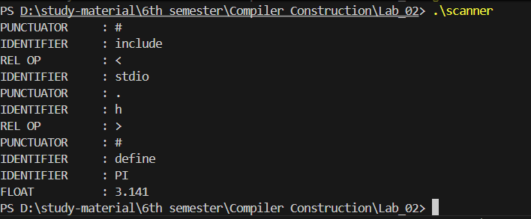

NOTE: Part II of this lab will add additional tasks to the same scanner implementation, so please ensure that you keep your implementation code in a safe place!

Deliverables
You are required to upload your task (Sources & Word/PDF document) using the link created on LMS followed by a viva or quiz.

Sources codes also given in this link:
Github.com

